The Correlation Between Traffic Violations and Motor Vehicle Collisions in NYC

CIS 4400 - CMWA

Cristopher Zuleta - [cristopher.zuleta@baruchmail.cuny.edu](mailto:christopher.zuleta@baruchmail.cuny.edu)

Steven Cai - [steven.cai@baruchmail.cuny.edu](mailto:steven.cai@baruchmail.cuny.edu)

Joshua Chirinos - [joshua.chirinos@baruchmail.cuny.edu](mailto:joshua.chirinos@baruchmail.cuny.edu)

Muhammad Megahed - [muhammad.megahed@baruchmail.cuny.edu](mailto:muhammad.megahed@baruchmail.cuny.edu)

Nazmus Sakib - [nazmus.sakib@baruchmail.cuny.edu](mailto:nazmus.sakib@baruchmail.cuny.edu)

Baruch College

Fall 2022

**Project Description:**

Our group decided to find a correlation between the status of the city streets and the occurrence of vehicle collisions. For this we will utilize fields from the 311 database such as: Street Condition, Street Light Condition, Traffic Signal Condition.

For this we will integrate the daily database of Motor Vehicles Collisions - Crashes to establish a correlation and a trend in behaviors/complaints. For example, we will try to establish correlations between inebriated drivers and the severity of any traffic violations. The goal of this project is to find possible solutions, based on the nature of the complaint and collision.

**Datasets:**

Motor Vehicle Collisions - Crashes

<https://data.cityofnewyork.us/Public-Safety/Motor-Vehicle-Collisions-Crashes/h9gi-nx95>

311 Service Requests from 2010 to Present

<https://data.cityofnewyork.us/Social-Services/311-Service-Requests-from-2010-to-Present/erm2-nwe9>

**KPIs:**

* Number of accidents per Zip Code.
* Number of accidents per Street.
* Number of complaints per Borough.
* Number of fatal injuries
* Number of non-fatal injuries
* Number of fatal collisions per factor
* Number of non-fatal collisions per factor
* Number of accidents by contributing factor
* Number of accidents by Latitude and Longitude
* Number of accidents by hour of the day
* Number of people injured by accident
* Number of people killed by accident

**Milestone 2:**

**Milestone #3:**

Updated Models:

* 311 Model:

* Crash Model:

* Combined Model:

**Milestone #4:**

ETL Tool and Target DBMS

To implement our project, we will be using Google BigQuery and for our ETL tool we will be using DBT. We came to this decision after a group discussion and agree that all members feel comfortable and capable of contributing to the project while working on this platform.

**Milestone #5:** ETL Programming

Data Profiling using Python for the 311_data and collisions_data between 2019 and 2022:

* Had an error with the 311 data but upon checking the report file, everything seemed to look good:

**311_data: **

* Alerts varied between High Cardinality, Constant, High correlation, Missing, Unsupported, and one alert of Unique

**Collisions_data: **

* Alerts varied between High Cardinality, High correlation, Missing, Uniform, Zeros and one alert of Unique

**In DBT:**

* Created 2 folders within the models’ folder:
  + core: for the data and the fact tables.
  + Staging: for the dimensions
* Created 3 folders within the staging folder:
  + 311: for the 311 dimensions
  + collisions: for the collision dimensions
  + shared_models: for the shared dimensions (date, time, location)

**core:**

* 311_data.sql query and fixing:

with all_data as (

  select

    unique_key,

    PARSE_DATETIME("%m/%d/%Y %I:%M:%S %p", TRIM(created_date)) AS created_date,

    PARSE_DATETIME("%m/%d/%Y %I:%M:%S %p", TRIM(closed_date)) AS closed_date,

    agency,

    agency_name,

    complaint_type,

    descriptor,

    location_type,

    incident_zip,

    incident_address,

    street_name,

    cross_street_1,

    cross_street_2,

    intersection_street_1,

    intersection_street_2,

    address_type,

    city,

    landmark,

    facility_type,

    status,

    PARSE_DATETIME("%m/%d/%Y %I:%M:%S %p", TRIM(due_date)) AS due_date,

    resolution_description,

    PARSE_DATETIME("%m/%d/%Y %I:%M:%S %p", TRIM(resolution_action_updated_date)) AS resolution_action_updated_date,

    community_board,

    bbl,

    borough,

    x_coordinate,

    y_coordinate,

    open_data_channel_type,

    park_facility_name,

    park_borough,

    vehicle_type,

    taxi_company_borough,

    taxi_pick_up_location,

    bridge_highway_name,

    bridge_highway_direction,

    road_ramp,

    bridge_highway_segment,

    latitude,

    longitude,

    location

  from

      {{ source ('project4400team10', '311model')}}

)

select

  unique_key,

  cast(FORMAT_DATE("%Y-%m-%d", created_date) as date) as created_date,

  format_timestamp("%H:%M:%S", created_date) as created_time,

  cast(FORMAT_DATE("%Y-%m-%d", closed_date) as date) as closed_date,

  format_timestamp("%H:%M:%S", closed_date) as closed_time,

  coalesce(agency, "Not Available") as agency,

  coalesce(agency_name, "Not Available")  as agency_name,

  CAST(complaint_type AS string) as complaint_type,

  coalesce(descriptor, "Unknown") as descriptor,

  coalesce(location_type, "Not Available") as location_type,

  coalesce(incident_zip, "Not Available") as incident_zip,

  coalesce(incident_address, "Not Available") as incident_address,

  street_name,

  cross_street_1,

  cross_street_2,

  concat(coalesce(street_name, "Unknown"), " and ", coalesce(cross_street_1, "Unknown")) as intersecting_streets,

  intersection_street_1,

  intersection_street_2,

  address_type,

  coalesce(city, "Not Available") as city,

  landmark,

  facility_type,

  status,

  cast(FORMAT_DATE("%Y-%m-%d", due_date) as date) as due_date,

  format_timestamp("%H:%M:%S", due_date) as due_time,

  resolution_description,

  cast(FORMAT_DATE("%Y-%m-%d", resolution_action_updated_date) as date) as resolution_action_updated_date,

  format_timestamp("%H:%M:%S", resolution_action_updated_date) as resolution_action_updated_time,

  community_board,

  bbl,

  coalesce(borough, "Not Available") as borough,

  x_coordinate,

  y_coordinate,

  open_data_channel_type,

  park_facility_name,

  park_borough,

  vehicle_type,

  taxi_company_borough,

  taxi_pick_up_location,

  bridge_highway_name,

  bridge_highway_direction,

  road_ramp,

  bridge_highway_segment,

  coalesce(round(latitude, 6), 0.0) as latitude,

  coalesce(round(longitude, 6), 0.0) as longitude,

  location

from all_data

WHERE created_date BETWEEN '2019-07-01' AND '2022-11-28'

AND complaint_type = "Street Condition"

AND latitude IS NOT NULL

AND longitude IS NOT NULL

* Collisions_data.sql query:

with corrected as (

  select

    crash_date,

    case

      when crash_time like '_:__' then concat('0', crash_time)

      else crash_time

      end as crash_time,

    borough,

    zip_code,

    latitude,

    longitude,

    location,

    on_street_name,

    cross_street_name,

    concat(coalesce(on_street_name, "Unknown"), " and ", coalesce(cross_street_name, "Unknown")) as intersecting_streets,

    off_street_name,

    number_of_persons_injured,

    number_of_persons_killed,

    number_of_pedestrians_injured,

    number_of_pedestrians_killed,

    number_of_cyclist_injured,

    number_of_cyclist_killed,

    number_of_motorist_injured,

    number_of_motorist_killed,

    contributing_factor_vehicle_1,

    contributing_factor_vehicle_2,

    contributing_factor_vehicle_3,

    contributing_factor_vehicle_4,

    contributing_factor_vehicle_5,

    collision_id,

    vehicle_type_code_1,

    vehicle_type_code_2,

    vehicle_type_code_3,

    vehicle_type_code_4,

    vehicle_type_code_5

  from

    {{ source ('project4400team10', 'collisions')}}

  WHERE

    latitude != 0

    AND latitude IS NOT NULL

    AND longitude != 0

    AND longitude IS NOT NULL

    AND borough IS NOT NULL

    AND zip_code IS NOT NULL

)

select

  crash_date,

  CAST(PARSE_TIME("%H:%M", crash_time) AS STRING) as crash_time,

  borough,

  cast(zip_code as STRING) as zip_code,

  round(latitude, 6) as latitude,

  round(longitude, 6) as longitude,

  location,

  on_street_name,

  cross_street_name,

  intersecting_streets,

  off_street_name,

  number_of_persons_injured,

  number_of_persons_killed,

  number_of_pedestrians_injured,

  number_of_pedestrians_killed,

  number_of_cyclist_injured,

  number_of_cyclist_killed,

  number_of_motorist_injured,

  number_of_motorist_killed,

  coalesce(CONTRIBUTING_FACTOR_VEHICLE_1, "Unspecified") as CONTRIBUTING_FACTOR_VEHICLE_1,

  coalesce(CONTRIBUTING_FACTOR_VEHICLE_2, "Unspecified") as CONTRIBUTING_FACTOR_VEHICLE_2,

  contributing_factor_vehicle_3,

  contributing_factor_vehicle_4,

  contributing_factor_vehicle_5,

  collision_id,

  coalesce(vehicle_type_code_1, "Unknown") as vehicle_type_code_1,

  coalesce(vehicle_type_code_2, "Unknown") as vehicle_type_code_2,

  vehicle_type_code_3,

  vehicle_type_code_4,

  vehicle_type_code_5

from

  corrected

WHERE crash_date BETWEEN '2019-07-01' AND '2022-11-28'

**staging:**

* **311:**
  + 311_location.sql

with location_dim as (

  select distinct

    location_type,

    incident_address,

    incident_zip,

    intersecting_streets,

    city,

    borough,

    latitude,

    longitude

  from

    {{ ref ('311_data')}}

)

select

  row_number() over () as location_dim_id,

  location_type,

  incident_address,

  incident_zip,

  intersecting_streets,

  city,

  borough,

  latitude,

  longitude

from

  location_dim

* + agency_type.sql

with agency_dim as (

  select distinct

    agency,

    agency_name

  from

    {{ ref ('311_data')}}

)

select

  row_number() over () as agency_type_dim_id,

  agency,

  agency_name

from

  agency_dim

* + channel_type.sql

with channel_dim as (

  select distinct

    open_data_channel_type as open_data_channel_type

  from

    {{ ref ('311_data')}}

)

select

  row_number() over () as channel_type_dim_id,

  open_data_channel_type,

from

  channel_dim

* + complaint_type.sql

with complaint as (

    select distinct

        complaint_type,

        descriptor

    from {{ ref ('311_data')}}

)

select

row_number() over () as complaint_type_dim_id,

complaint_type,

descriptor

from complaint

* + status.sql

with status_dimension as (

  select distinct

    status as status

  from

    {{ ref ('311_data')}}

)

select

  row_number() over () as status_dim_id,

  status,

from

  status_dimension

* **collisions:**
  + collision.sql

with collision_dim as (

  select distinct

    vehicle_type_code_1,

    vehicle_type_code_2

  from

    {{ ref ('collisions_data')}}

)

select

  row_number() over () as collision_dim_id,

  *

from

  collision_dim

* + collisions_location.sql

with location_dim as (

  select distinct

    intersecting_streets,

    borough,

    zip_code,

    latitude,

    longitude

  from

    {{ ref ('collisions_data')}}

)

select

  row_number() over () as location_dim_id,

  *

from

  location_dim

* + factors.sql

with factors_dim as (

  select distinct

    CONTRIBUTING_FACTOR_VEHICLE_1,

    CONTRIBUTING_FACTOR_VEHICLE_2

  from

    {{ ref ('collisions_data')}}

)

select

  row_number() over () as factors_dim_id,

  *

from

  factors_dim

* + fatalities.sql

with fatal_dim as (

  select distinct

    number_of_persons_killed,

    number_of_pedestrians_killed,

    number_of_cyclist_killed,

    number_of_motorist_killed

  from

    {{ ref ('collisions_data')}}

)

select

  row_number() over () as fatalities_dim_id,

  *

from

  fatal_dim

* + injuries.sql

with injur_dim as (

  select distinct

    number_of_persons_injured,

    number_of_pedestrians_injured,

    number_of_cyclist_injured,

    number_of_motorist_injured

  from

    {{ ref ('collisions_data')}}

)

select

  row_number() over () as injuries_dim_id,

  *

from

  injur_dim

* **shared_models**
  + date_dimension.sql (day as the lowest grain using “generate_date_array”)

SELECT

  row_number() over () as date_dim_id,

  d as full_date,

  EXTRACT(YEAR FROM d) AS year,

  EXTRACT(MONTH FROM d) AS month,

  EXTRACT(DAY FROM d) AS day,

FROM (

  SELECT

    *

  FROM

    UNNEST(GENERATE_DATE_ARRAY('2016-10-01', '2022-11-28', INTERVAL 1 DAY)) AS d )

* + time_dimension.sql (second as the lowest grain using “generate_timestamp_array”)

SELECT

  row_number() over () as time_dim_id,

  format_timestamp("%H:%M:%S", t) as full_time,

  EXTRACT(HOUR FROM t) AS hour,

  EXTRACT(MINUTE FROM t) AS minute,

  EXTRACT(SECOND FROM t) AS second

FROM (

  SELECT

    *

  FROM

    UNNEST(GENERATE_TIMESTAMP_ARRAY('2010-01-01', '2010-01-02', INTERVAL 1 SECOND)) AS t )

* + location_dimension.sql (generated from the two staging locations made earlier)

with complaint_location as (

    select *

    from {{ref ("311_location")}}

),

collision_location as (

    select *

    from {{ref ("collisions_location")}}

),

location_dimension as (

    select

        location_type,

        coalesce(complaint_location.intersecting_streets, collision_location.intersecting_streets, "Not Applicable") as intersecting_streets,

        coalesce(complaint_location.incident_zip, collision_location.zip_code) as zip_code,

        coalesce(complaint_location.borough, collision_location.borough) as borough,

        coalesce(complaint_location.latitude, collision_location.latitude) as latitude,

        coalesce(complaint_location.longitude, collision_location.longitude) as longitude

    from

        complaint_location

        full join collision_location

        on complaint_location.latitude = collision_location.latitude

        and complaint_location.longitude = collision_location.longitude

)

select

    row_number() over () as location_dim_id,

    *

from

    location_dimension

* **core (fact tables)**
  + fct_311.sql with screenshot of preview

{{ config(

    materialized='table'

)}}

with location as (

    select *

    from {{ ref ("location_dimension")}}

),

agency as (

    select *

    from {{ ref ("agency_type")}}

),

channel as (

    select *

    from {{ ref ("channel_type")}}

),

complaint as (

    select *

    from {{ ref ("311_data")}}

),

complaint_types as (

    select *

    from {{ ref ("complaint_type")}}

),

status as (

    select *

    from {{ ref ("status")}}

),

dates as (

    select *

    from {{ ref ("date_dimension")}}

),

times as (

    select *

    from {{ ref("time_dimension")}}

),

fact_table as (

    select

        complaint.unique_key,

        complaint_types.complaint_type_dim_id,

        agency.agency_type_dim_id,

        dates.date_dim_id,

        times.time_dim_id,

        location.location_dim_id,

        channel.channel_type_dim_id,

        status.status_dim_id

    from

        complaint

    left join agency on complaint.agency = agency.agency

    and complaint.agency_name = agency.agency_name

    left join complaint_types on complaint.complaint_type = complaint_types.complaint_type

    and complaint.descriptor = complaint_types.descriptor

    left join dates on complaint.created_date = dates.full_date

    left join times on complaint.created_time = times.full_time

    left join location on complaint.intersecting_streets = location.intersecting_streets

    and complaint.incident_zip = location.zip_code

    and complaint.latitude = location.latitude

    and complaint.longitude = location.longitude

    and complaint.location_type = location.location_type

    left join channel on complaint.open_data_channel_type = channel.open_data_channel_type

    left join status on complaint.status = status.status

)

select *

from fact_table

* + fct_collisions.sql with screenshot of preview

{{ config(

    materialized='table'

)}}

with collisions as (

    select *

    from {{ ref ("collisions_data")}}

),

collision as (

    select *

    from {{ ref ("collision")}}

),

location as (

    select *

    from {{ ref ("location_dimension")}}

),

factors as (

    select *

    from {{ ref ("factors")}}

),

fatalities as (

    select *

    from {{ ref ("fatalities")}}

),

injuries as (

    select *

    from {{ ref ("injuries")}}

),

dates as (

    select *

    from {{ ref ("date_dimension")}}

),

times as (

    select *

    from {{ ref ("time_dimension")}}

),

fact_table as (

    select

        collisions.collision_id,

        collision.collision_dim_id,

        location.location_dim_id,

        factors.factors_dim_id,

        fatalities.fatalities_dim_id,

        injuries.injuries_dim_id,

        dates.date_dim_id,

        times.time_dim_id

    from

        collisions

    left join collision on collisions.vehicle_type_code_1 = collision.vehicle_type_code_1

    and collisions.vehicle_type_code_2 = collision.vehicle_type_code_2

    left join location on collisions.intersecting_streets = location.intersecting_streets

    and collisions.zip_code = location.zip_code

    and collisions.latitude = location.latitude

    and collisions.longitude = location.longitude

    left join factors on collisions.CONTRIBUTING_FACTOR_VEHICLE_1 = factors.CONTRIBUTING_FACTOR_VEHICLE_1

    and collisions.CONTRIBUTING_FACTOR_VEHICLE_2 = factors.CONTRIBUTING_FACTOR_VEHICLE_2

    left join fatalities on collisions.number_of_persons_killed = fatalities.number_of_persons_killed

    and collisions.number_of_pedestrians_killed = fatalities.number_of_pedestrians_killed

    and collisions.number_of_cyclist_killed = fatalities.number_of_cyclist_killed

    and collisions.number_of_motorist_killed = fatalities.number_of_motorist_killed

    left join injuries on collisions.number_of_persons_injured = injuries.number_of_persons_injured

    and collisions.number_of_pedestrians_injured = injuries.number_of_pedestrians_injured

    and collisions.number_of_cyclist_injured = injuries.number_of_cyclist_injured

    and collisions.number_of_motorist_injured = injuries.number_of_motorist_injured

    left join dates on collisions.crash_date = dates.full_date

    left join times on collisions.crash_time = times.full_time

)

select *

from fact_table

* **YML and MD files and their content**
  + sources.yml (destination and documentation for sources)

* + core.yml (documentation for 311_data, collisions_data, and fact tables)

* + 311.yml (documentation for 311 dimensions)

* + 311.md (documentation for status column made using a table)

* + collisions.yml (documentation for collisions dimestions)

* + dbt_project.yml

* Directory overview:

* DBT commands:

* Final DAG

* BigQuery overview:

* **Final view of the dimensional model:**

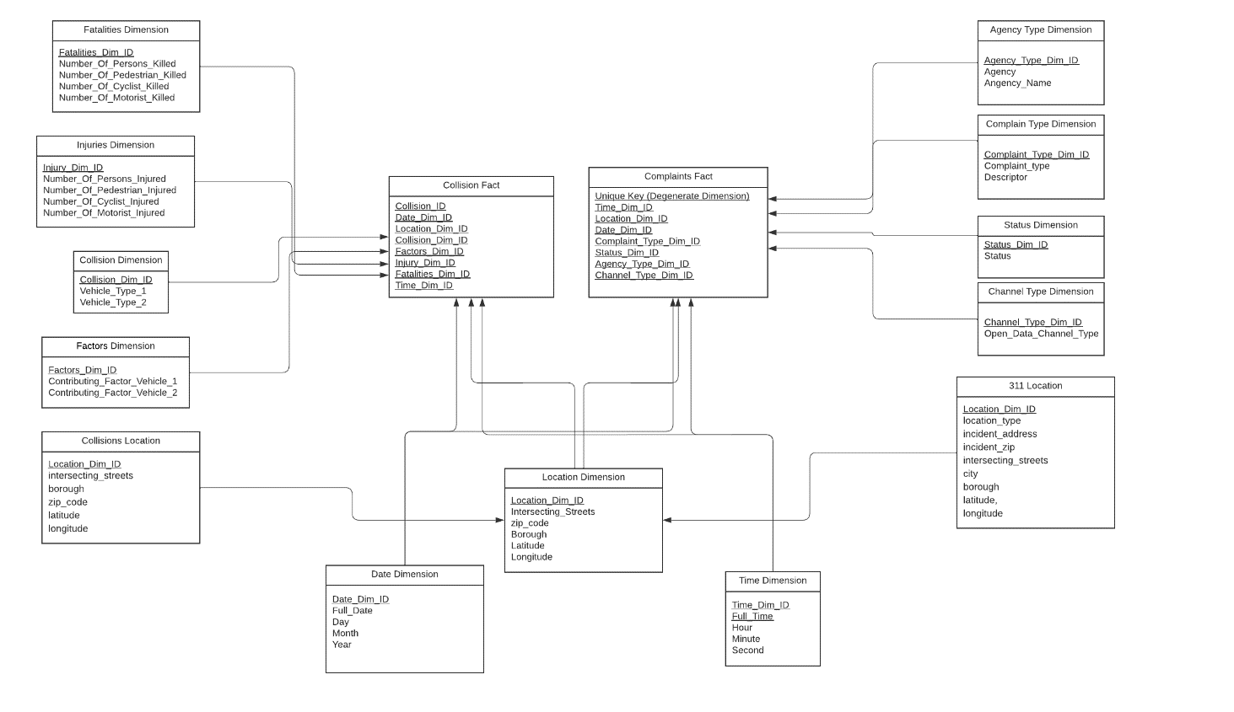

* + The 311 data had five staging models: status, complaint_type, agency_type, channel_type, and the 311 location dimension.
  + The collisions data had five staging models: factors, collisions, fatalities, injuries, and the collisions’ location dimension.
  + The 311 location dimension and the collisions’ location dimension were used to create the location dimension for the fact tables.
  + The date and time dimensions were created generically using SQL functions and linked to the fact table. The format for time and data were also matched with the ones in 311 data and the collisions data.
* **Bi Application**

The BI and Data Visualization tool was used to create a dashboard application consisting of four sheets to help users navigate through the important aspects of the data easily and be informed on some of the important KPIs:

* + **Number of Injuries:**

This visualization was created using columns from the injuries dimension and the “full date” column in the date dimension. The type of injured personnel was used as a color filter.

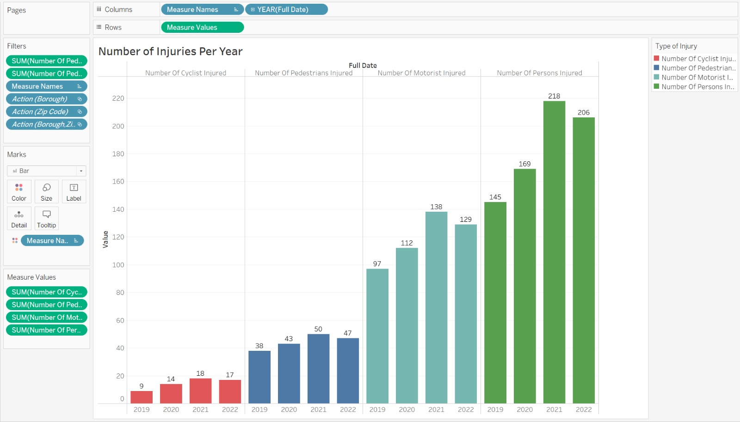

* + **Number of Fatalities**

This visualization was created using columns from the fatalities dimension and the “full date” column in the date dimension. The type of personnel involved was used as a color filter.

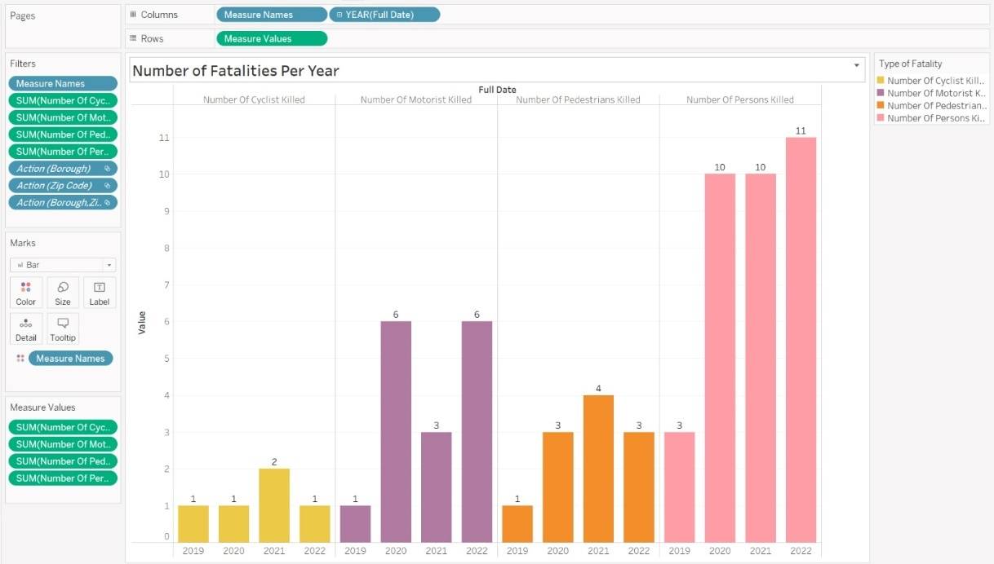

* + **Number of Collisions Per Zip code**

This was a direct visualization that we created using the zip code and the collision id column from the fact table. The collision Id had to be changed to a measure and used “count” the aggregate. Also, Borough was used as a color filter

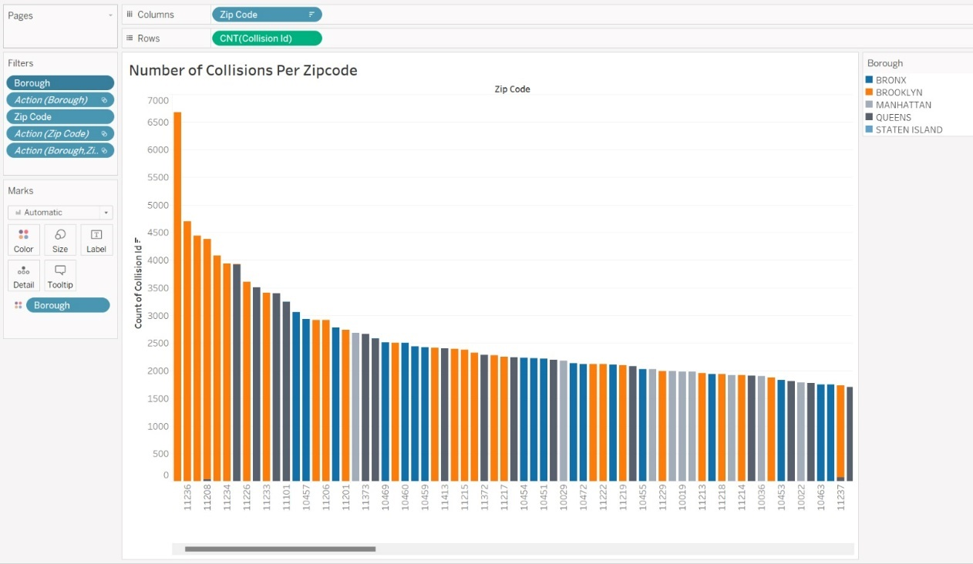

* + **Zip Code Map:**

This visualization was created using the longitude and latitude as measures, zip code as the details, and borough as a color filter.

We also created a search parameter for this sheet that takes any zip code as a value, and the parameter was also added to the dashboard application.

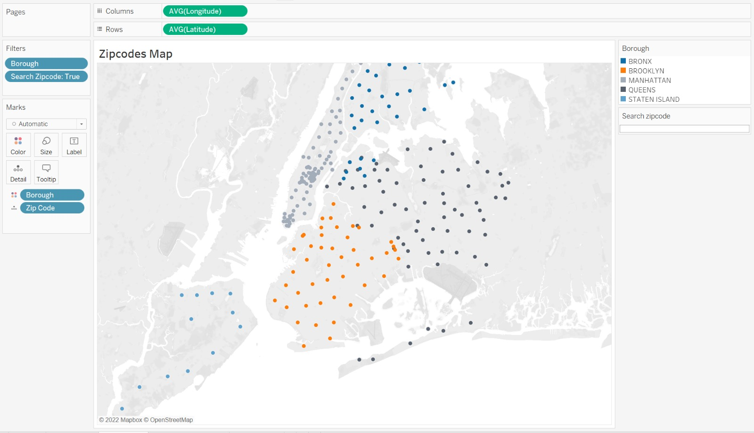

* + **Dashboard**

The dashboard consists of the four sheets above and uses the “zip code map” sheet as a filter. The “search zip code” parameter was also added to the dashboard.

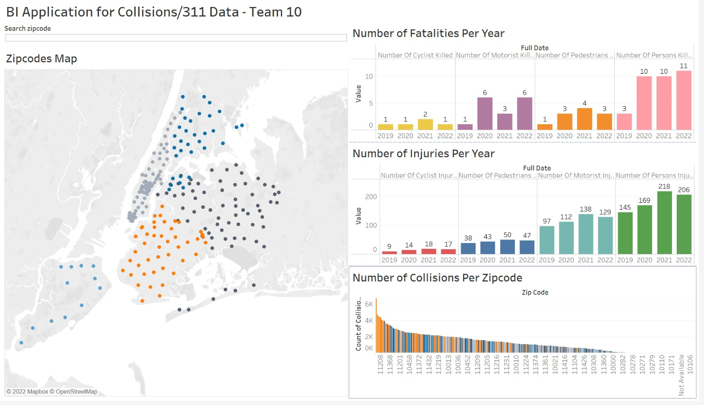

* + Link:

The dashboard was uploaded to Tableau Public and can be accessed and used by clicking this link:

[BI Application for Collisions/311 Data - Team 10](https://public.tableau.com/app/profile/muhammad.megahed/viz/BIApplicationforCollisions311Data-Team10/Dashboard1?publish=yes)

* **Tools and Applications Used**

To complete our project, we used several tools. Some of the tools we utilized are database tools, visualization tool, ETL (extract, transform, load) tools, and programming languages.

Database are used to store, organize, and manage data in a structured way. Therefore, we used Google BigQuery as our target DBMS (Database Management Systems) to find a correlation between the status of the city streets and vehicle collisions. To find the correlations, we utilized the data collected from the 311 and Motor Vehicle Collisions databases.

Visualizations are a graphical representation of data, such as charts, graphs, and maps. We utilized Lucid Chart to create our three dimensional model diagrams: 311 Model, Crash Model, and Combined Model. In addition, DBT generates a DAG (Directed Acyclic Graph) for our project. Tableau was used to create a BI application consisting of visualizations that help the user navigate through the data and visualize important KPIs.

ETL tools are used to extract data from multiple sources, transform the data into a standardized format, and load it into a destination, such as a database. The ETL tool we used for this project was DBT. DBT made it easier to work with large and complex datasets.

Programming languages are used to execute code that can solve a wide range of questions or problems. We utilized SQL and Python in our project. SQL was used in Google BigQuery to test queries and in DBT to create dimensions. Python was used for our data profiling on 311_data and collisions_data.

* **Conclusion**

For the group project, our team used a variety of software and database tools to successfully complete and coordinate our milestones. The mentioned tools are listed below:

* + WhatsApp - to plan out the project, store our notes/important information, and assign tasks to the whole team.
  + Zoom - to facilitate our meetings.
  + LucidChart - to create our data models like our three dimensional data models.
  + DBT - to handle communication with BigQuery so that we can process requests
  + BigQuery - to store our large dataset and run SQL commands on
  + Tableau - used to create visualizations for our data like the KPIs
  + Python & Jupyterlab - to run scripts to complete the database requirements for the project.

Overall, we had a very pleasant experience with the project. It was genuinely a great experience being able to work with people who were willing to put in the work needed to complete the project. WhatsApp and Zoom were our main methods of communication and coordination, and they were a great help in us working on and finishing the milestones before the deadlines.

The changes that we proposed for a future attempt at the project are at their core very simple foundational steps that would have made it easier for us to build the project on top of. In essence we basically needed better communication and preparation during, before and after meetings. Something of that nature is very feasible for a group to accomplish and would always guarantee a better experience/final product because of the higher quality of the input used to create the end result.

I think maybe for next year’s class on Data Warehousing there should be a bigger focus on NoSQL databases and unstructured data. While we spent a lot of time on SQL and SQL databases in class which led to it being what we used for our project I would have loved to approach this project with a NoSQL database like DynamoDB or FireStore, but unfortunately since we did not spend enough time on it in class the entire team did not feel comfortable with it, therefore, we decided to use SQL. It would be great for students next year to have more time being spent on NoSQL databases which are just as important as SQL databases.

* **Meeting Logs**

| **Date** | **Time Started - Time Ended** | **Members Present** | **What We Discussed** | **Platform** |
| --- | --- | --- | --- | --- |
| 9/21/2022 | 12:00PM - 1:30PM | Nazmus,  Steven,  Muhammad,  Christopher,  Joshua | Accomplishing Milestone 1.  Trying to workout our individual schedules.  Finding data models to use.  Establishing our KPIs. | Zoom |
| 10/07/2022 | 8:30PM -10:30PM | Nazmus,  Steven,  Muhammad,  Christopher,  Joshua | Accomplishing Milestone 2.  New KPIs based on feedback.  Dimensional Modeling. | Zoom |
| 10/20/2022 | 7:00PM-8:00PM | Nazmus,  Steven,  Muhammad,  Christopher,  Joshua | Accomplishing Milestone 3  Finalizing Dimensional Model | Zoom |
| 11/13/2022 | 7:00PM-8:00PM | Nazmus,  Steven,  Muhammad,  Christopher,  Joshua | Accomplishing Milestone 4. | Zoom |
| 11/28/2022 | 9:00PM-10:00PM | Nazmus,  Steven,  Muhammad,  Christopher,  Joshua | Discussion regarding Milestone 5. | Zoom |
| 12/06/2022 | 7:00PM-8:00PM | Nazmus,  Steven,  Muhammad,  Christopher,  Joshua | Follow-up on Milestone 5. | Zoom |
| 12/09/2022 | 9:00PM-10:00PM | Nazmus,  Steven,  Muhammad,  Christopher,  Joshua | Finalizing  Milestone 5. | Zoom |

* **Referneces:**
* <https://lucid.app/> - LucidChart for creating the Models
* <https://console.cloud.google.com/bigquery> – BigQuery from Google Cloud for the target DMBS.
* <https://cloud.google.com/bigquery/docs/reference/> - BigQuery Documentation for functions and syntax.
* <https://docs.getdbt.com/reference/dbt_project.yml> – DBT documentation for edits to default files and navigation through the Develop and Deploy hub.
* <https://courses.getdbt.com/courses/fundamentals> – DBT Fundementals course from homework 3 was a great reference in building the dimensions and creating documentation.
* <https://courses.getdbt.com/courses/jinja-macros-packages> – Jinja Course from homework 3 was a great reference to Jinja syntax.
* <https://zoom.us/> - Zoom for hosting meetings to finish milestones.
* <https://www.tableau.com/products/desktop/download> – For creating the BI application for the project.
* <https://stackoverflow.com/> - Answered a lot of questions that we encountered throughout the project.
* <https://www.w3schools.com/sql/> - A quick refresher to some of the needed SQL functions like coalesce( ).
* <https://docs.python.org/3/> - Used to check error messages and to review for the data profiling process.